**ABC Pantry feature for E-Commerce website**

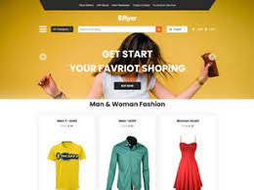

**Submitted by:**

Mohit Pal

Table of Contents

1- Introduction 3

Business Analysis Core Concept Model (BACCM) 3

2- Identify stakeholders 4

3- The proposed system workflow 5

As-Is Process map: 5

Future Process map: 5

4- Finding the Scope of ABC Pantry feature (Context Diagram) 6

Main features of ABS Pantry 6

5- The In-scope and Out of Scope Items for ABC PANTRY FEATURE 7

9- Key functional and Non-functional requirements 7

6- Wireframe for Update menu page and table booking 8

Personal Care Products Page 8

Place Order Page 9

7-User stories and Acceptance criteria 9

8-Sales Analysis by Region on Tableau 10

Personal care products sales of Chicago city 10

8.2 Breakfast Product sales of Chicago city 10

9- Excel Work 11

9.1-Sales report of Daily essential products 11

9.1.2.1-Ascending order of sales 11

9.1.2.2-Decending order by sales 12

9.2-Sales of Zone 1 12

9.3-Find Sales 13

9.2.1- Product code HS, find sales in Phoenix 13

9.2.2- Product code FR, find sales in Dallas 13

# 1- Introduction

ABC Company is the world’s leading online e-commerce company. They started by selling books and now have a presence across the world selling more than 6 million items globally.

Most of the products that dominate ABC Company’s sales are non-essential products like fashion products, electronic gadgets, mobile phones, beauty products, books and home furnishings. But ABC Company has realized that every household will need daily essential products like cereals, snacks, beverages, cleaning products, grooming products and so on. ABC Company is seeing a huge market globally in Daily Essential Products and wants to venture into this side of business.

ABC Company decided to create a new feature known as ABC Pantry which would sell daily essential products. This would be an additional enhancement in the current website/app. This would be ABC Company’s foray into daily essential products which are regular consumption products and would lead to repeat sales every month.

## Business Analysis Core Concept Model (BACCM)

# 2- Identify stakeholders

RACI matrix is used here for identifying the responsibility of each stakeholder involved in the process:

Responsible (R): The individuals who will be performing the work on the task.

Accountable (A): The individual who is ultimately answerable for the completion of the task and is the decision maker.

Consulted (C): The stakeholder (group) who will be asked to provide opinion or information about the task.

Informed (I): The stakeholder (group) that is kept up to date on the task and its outcome.

|  |  |  |  |  |
| --- | --- | --- | --- | --- |
| **Stakeholders** | **Responsible** | **Accountable** | **Consulted** | **Informed** |
| Project Manager |  | A |  |  |
| Implementation SME | R |  |  |  |
| Tester | R |  |  |  |
| Domain SME |  |  | C |  |
| Operational Support |  |  | C |  |
| Supplier |  |  |  | I |
| Business Analyst | R | A |  |  |
| Sponsor |  |  | C | I |
| End User |  |  |  | I |
| Customer |  |  |  | I |
| Regulators |  |  | C |  |

# 3- The proposed system workflow

## As-Is Process map:

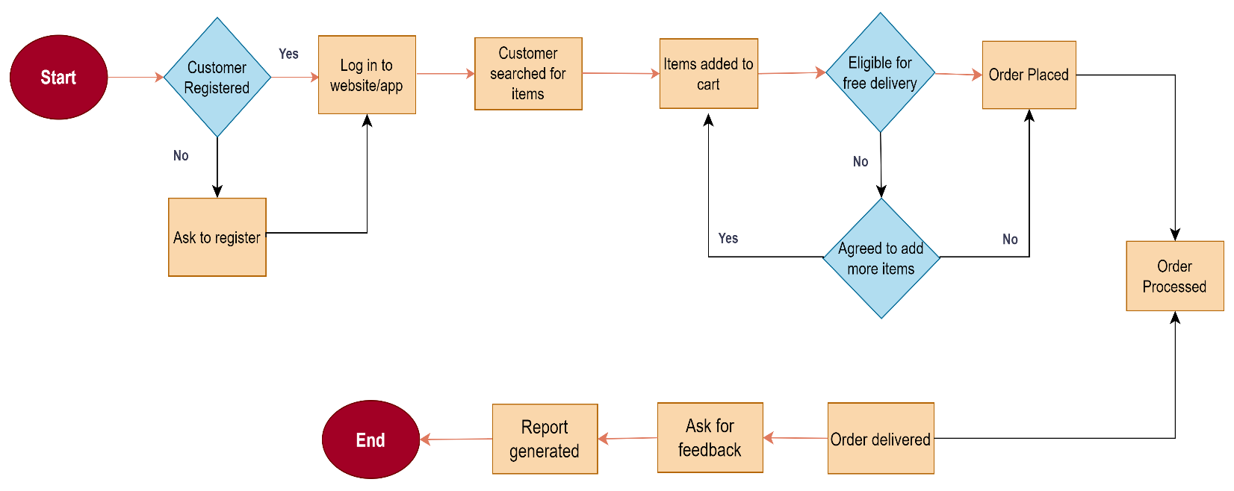

## Future Process map:

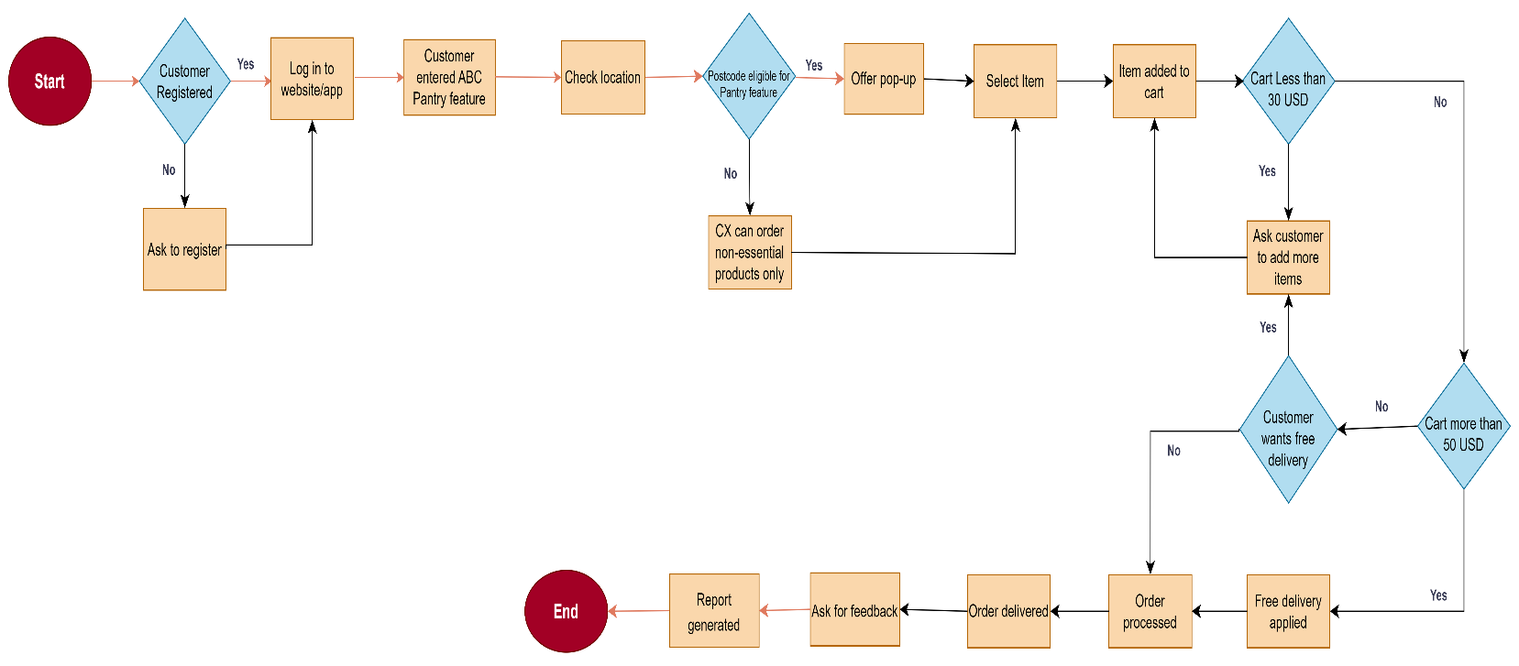

# 4- Finding the Scope of ABC Pantry feature (Context Diagram)

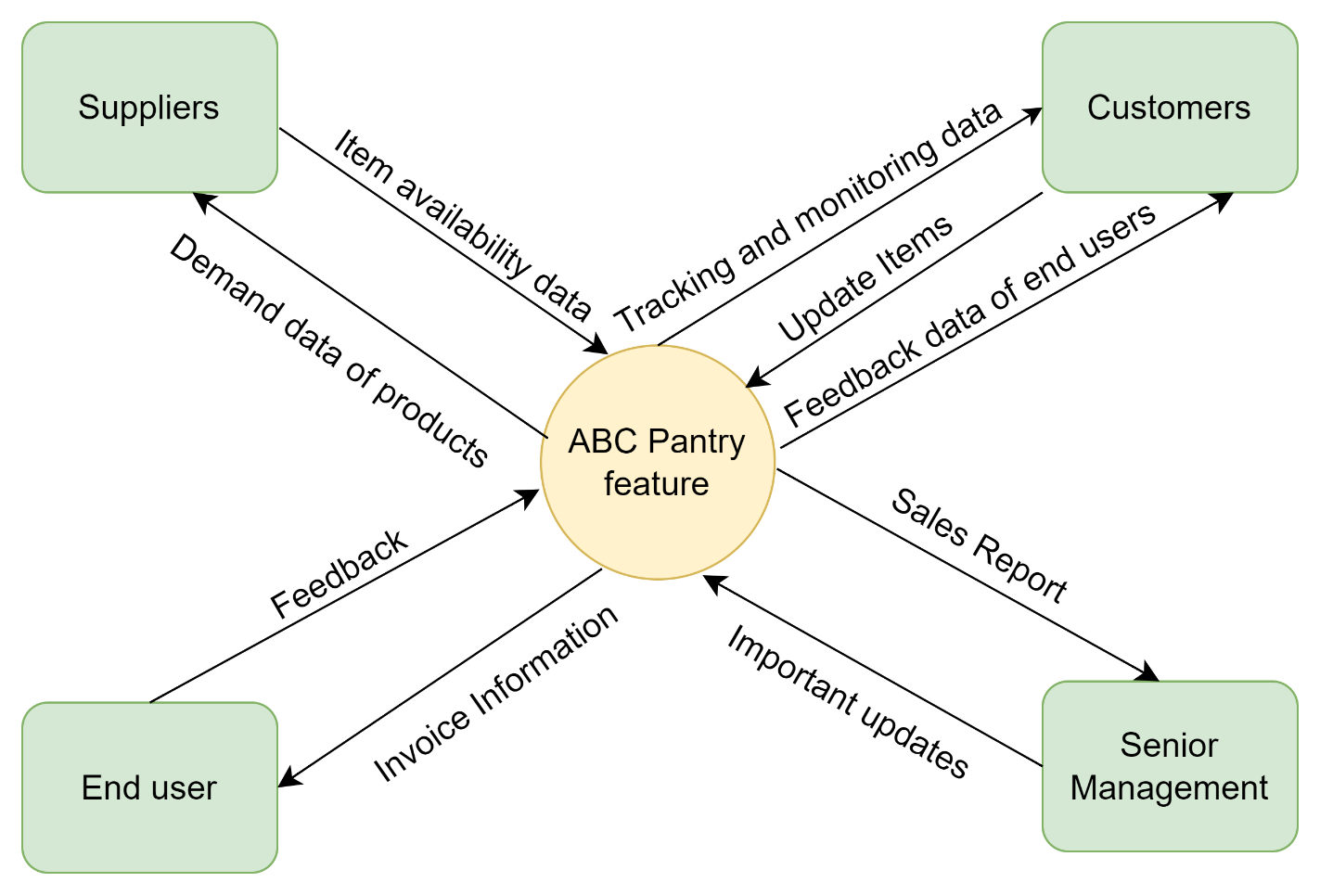

## Main features of ABS Pantry

1. Web-based Management System

* Must store data in cloud and operate with existing system
* Must have Flashing and blinking feature
* Must respond within 1 second
* Must be interactive and user-friendly
* Must be working all the times

1. Must open up a new range and categories of product
2. Prominent visibility on existing website and app
3. Logical grouping for customers
4. Able to show 5 advertisements
5. Feature to show certain offers
6. Invoice generation
7. Show feature only to certain cities
8. Reports for Senior management

* Total sales for each day
* Total sales for each product category as mentioned in point four.
* Total sales across USA
* Total sales for each city.
* Total sales for each zone that city falls into (that is, zone 1, 2, 3, and 4)
* Identify best-selling categories
* Identify the worst-selling categories
* Total sales of each week city wise
* Identify which day of the week shows highest booking by customers

# 5- The In-scope and Out of Scope Items for ABC PANTRY FEATURE

|  |  |
| --- | --- |
| **In-Scope Requirements** | **Out-of-Scope Requirements** |
| Availability of ABC PANTRY FEATURE on portal | Available only for certain cities |
| Open up a range of daily essential products | Only open a new range of products |
| Grouping of products | Grouping only on selected categories |
| Show 5 advertisement | Only show 5 advertisements |
| Online invoice generation | Generated only once order is placed |
| Feedback given by customers must be recorded | Only taken when status change to product delivered |
| Free delivery offered for orders more than $50 | Only offered for orders more than $50 |
| No order processing for orders less than $30 | Only process order if overall order price exceeds $30 |
| Billing and Reports generation | Reports must be generated at the end |

# 9- Key functional and Non-functional requirements

1. **Functional Requirements:**

* Availability of ABC Pantry feature on existing website/app
* New categories of products page
* Prominent visibility
* Customer’s feedback records
* Advertisements popup
* Offers popup
* Add to cart feature
* Order calculation
* Available Cities option
* Identify zones
* Payment gateway page

1. **Non-functional Requirements:**

* Cloud storage must be used
* The Creating and maintaining the program in Java
* The system shall be a web-based application.
* The system shall respond within 1 second
* The system shall keep logs of all the errors
* The system shall be available all the time
* The system should be self-explanatory and very user-friendly.

# 6- Wireframe for Update menu page and table booking

## Personal Care Products Page

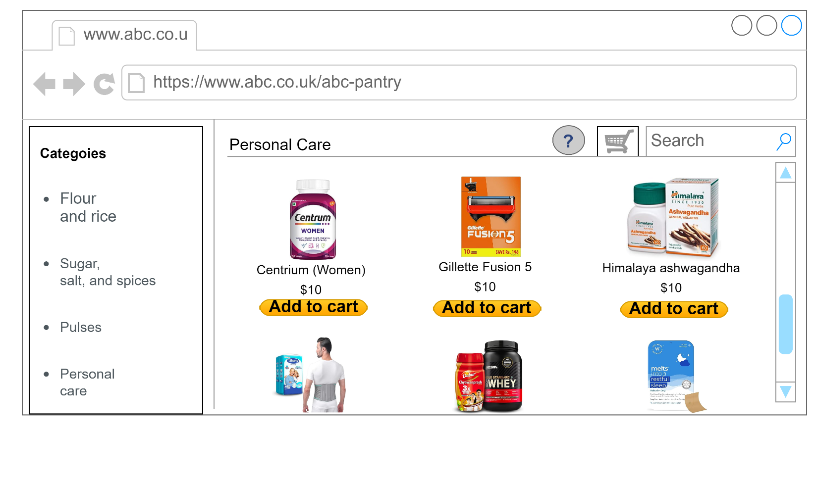

## Place Order Page

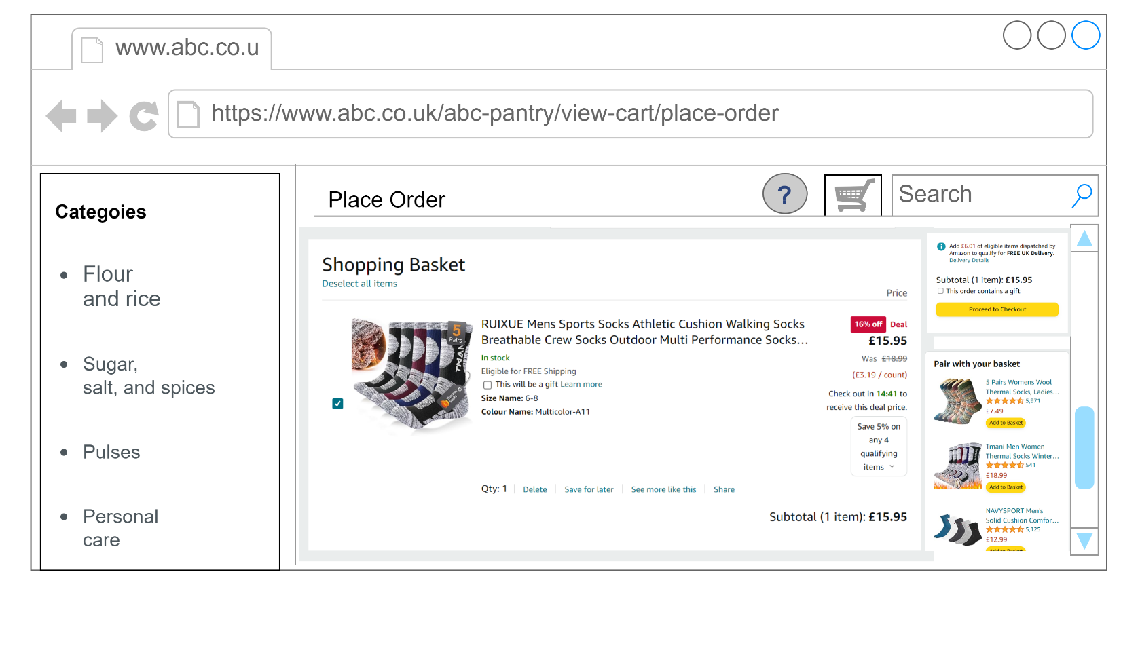

# 7-User stories and Acceptance criteria

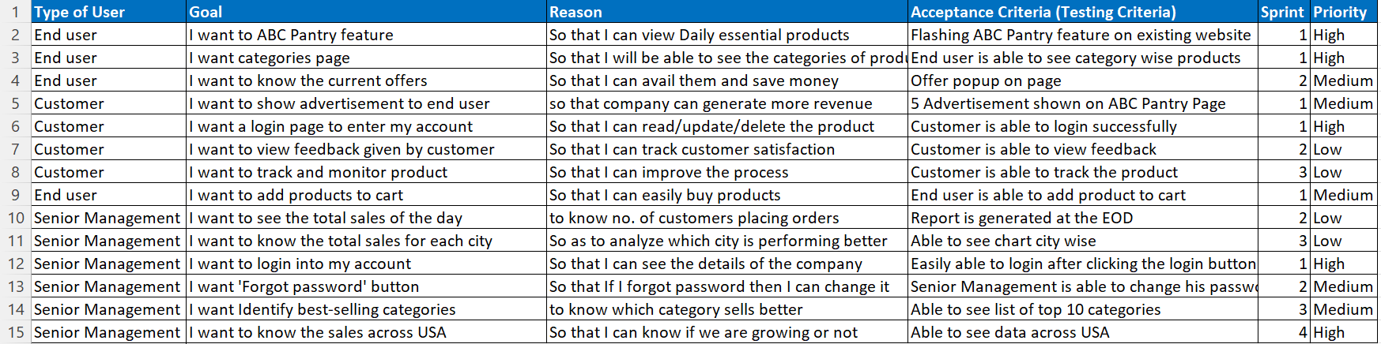

# 8-Sales Analysis by Region on Tableau

## Personal care products sales of Chicago city

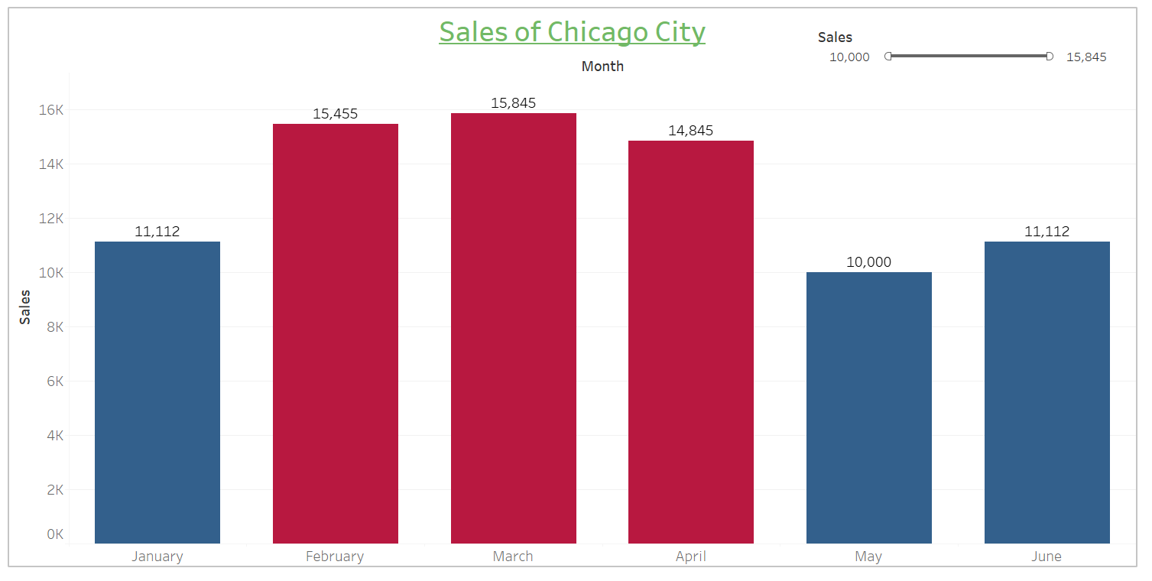

## 8.2 Breakfast Product sales of Chicago city

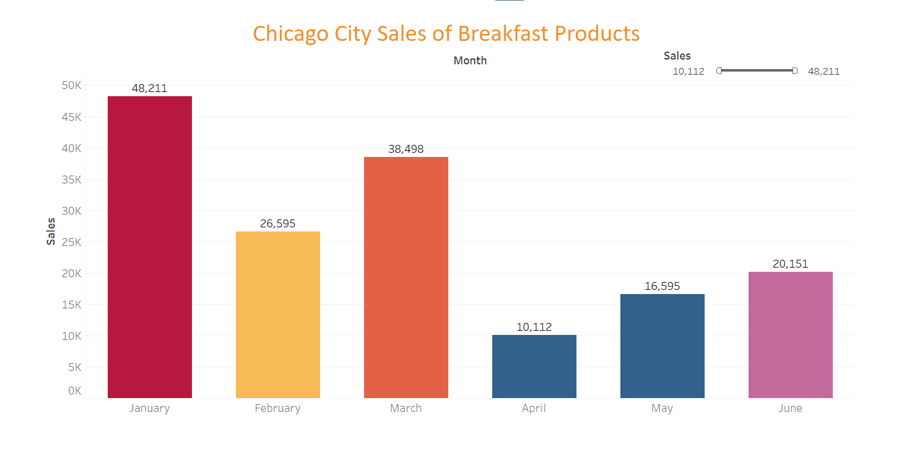

# 9- Excel Work

## 9.1-Sales report of Daily essential products

## 9.1.2.1-Ascending order of sales

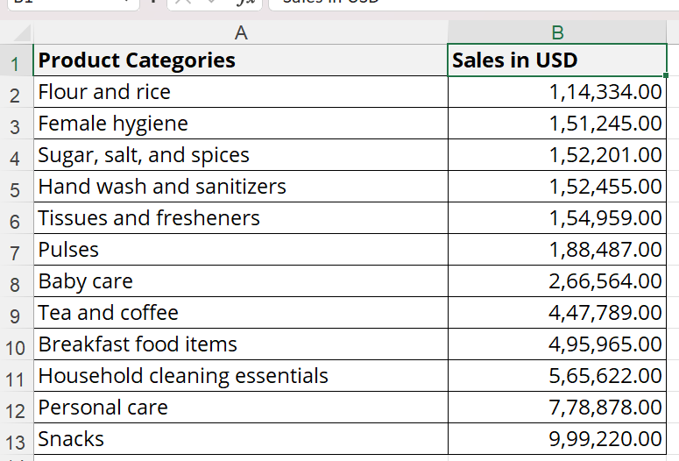

## 9.1.2.2-Decending order by sales

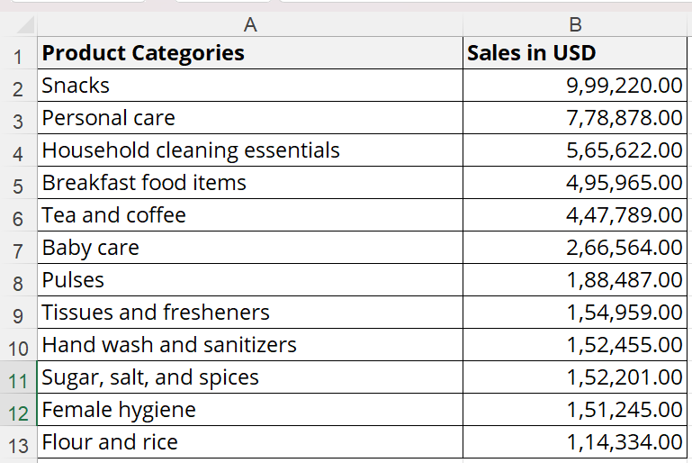

## 9.2-Sales of Zone 1

## 9.3-Find Sales

### 9.2.1- Product code HS, find sales in Phoenix

Answer- 1,544. Formulae: =VLOOKUP(HC,A1:N14,11,FALSE)

## 9.2.2- Product code FR, find sales in Dallas

Answer- 7895 Formulae: =VLOOKUP(FR,A1:N14,8,FALSE)